**P3. Consider the following network. With the indicated link costs, use Dijkstra’s shortest-path algorithm to compute the shortest path from x to all network nodes. Show how the algorithm works by computing a table similar to Table 5.1.**

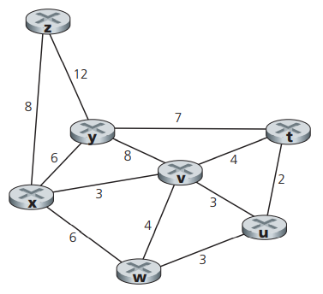

|  |  |  |  |  |  |  |  |
| --- | --- | --- | --- | --- | --- | --- | --- |
| Step | N’ | D(t),p(t) | D(u),p(u) | D(v),p(v) | D(w),p(w) | D(y),p(y) | D(z),p(z) |
| 0 | x | ∞ | ∞ | 3,x | 6,x | 6,x | 8,x |
| 1 | xv | 7,v | 6,v | 3,x | 6,x | 6,x | 8,x |
| 2 | xvu | 7,v | 6,v | 3,x | 6,x | 6,x | 8,x |
| 3 | xvuw | 7,v | 6,v | 3,x | 6,x | 6,x | 8,x |
| 4 | xvuwy | 7,v | 6,v | 3,x | 6,x | 6,x | 8,x |
| 5 | xvuwyt | 7,v | 6,v | 3,x | 6,x | 6,x | 8,x |
| 6 | xvuwytz | 7,v | 6,v | 3,x | 6,x | 6,x | 8,x |

**P4. Consider the network shown in Problem P3. Using Dijkstra’s algorithm, and showing your work using a table similar to Table 5.1, do the following:**

**a. Compute the shortest path from t to all network nodes.**

**b. Compute the shortest path from u to all network nodes.**

**c. Compute the shortest path from v to all network nodes.**

**d. Compute the shortest path from w to all network nodes.**

**e. Compute the shortest path from y to all network nodes.**

**f. Compute the shortest path from z to all network nodes.**

a)

|  |  |  |  |  |  |  |  |
| --- | --- | --- | --- | --- | --- | --- | --- |
| Step | N’ | D(x),p(x) | D(u),p(u) | D(v),p(v) | D(w),p(w) | D(y),p(y) | D(z),p(z) |
| 0 | t | ∞ | 2,t | 4,t | ∞ | 7,t | ∞ |
| 1 | tu | ∞ | 2,t | 4,t | 5,u | 7,t | ∞ |
| 2 | tuv | 7,v | 2,t | 4,t | 5,u | 7,t | ∞ |
| 3 | tuvw | 7,v | 2,t | 4,t | 5,u | 7,t | ∞ |
| 4 | tuvwx | 7,v | 2,t | 4,t | 5,u | 7,t | 15,x |
| 5 | tuvwxy | 7,v | 2,t | 4,t | 5,u | 7,t | 15,x |
| 6 | tuvwxyz | 7,v | 2,t | 4,t | 5,u | 7,t | 15,x |

b)

|  |  |  |  |  |  |  |  |
| --- | --- | --- | --- | --- | --- | --- | --- |
| Step | N’ | D(x),p(x) | D(t),p(t) | D(v),p(v) | D(w),p(w) | D(y),p(y) | D(z),p(z) |
| 0 | u | ∞ | 2,u | 3,u | 3,u | ∞ | ∞ |
| 1 | ut | ∞ | 2,u | 3,u | 3,u | 9,t | ∞ |
| 2 | utv | 6,v | 2,u | 3,u | 3,u | 9,t | ∞ |
| 3 | utvw | 6,v | 2,u | 3,u | 3,u | 9,t | ∞ |
| 4 | utvwx | 6,v | 2,u | 3,u | 3,u | 9,t | 14,x |
| 5 | utvwxy | 6,v | 2,u | 3,u | 3,u | 9,t | 14,x |
| 6 | utvwxyz | 6,v | 2,u | 3,u | 3,u | 9,t | 14,x |

c)

|  |  |  |  |  |  |  |  |
| --- | --- | --- | --- | --- | --- | --- | --- |
| Step | N’ | D(x),p(x) | D(u),p(u) | D(t),p(t) | D(w),p(w) | D(y),p(y) | D(z),p(z) |
| 0 | v | 3,v | 3,v | 4,v | 4,v | 8,v | ∞ |
| 1 | vx | 3,v | 3,v | 4,v | 4,v | 8,v | 11,x |
| 2 | vxu | 3,v | 3,v | 4,v | 4,v | 8,v | 11,x |
| 3 | vxut | 3,v | 3,v | 4,v | 4,v | 8,v | 11,x |
| 4 | vxutw | 3,v | 3,v | 4,v | 4,v | 8,v | 11,x |
| 5 | vxutwy | 3,v | 3,v | 4,v | 4,v | 8,v | 11,x |
| 6 | vxutwyz | 3,v | 3,v | 4,v | 4,v | 8,v | 11,x |

d)

|  |  |  |  |  |  |  |  |
| --- | --- | --- | --- | --- | --- | --- | --- |
| Step | N’ | D(x),p(x) | D(u),p(u) | D(v),p(v) | D(t),p(t) | D(y),p(y) | D(z),p(z) |
| 0 | w | 6,w | 3,w | 4,w | ∞ | ∞ | ∞ |
| 1 | wu | 6,w | 3,w | 4,w | 5,u | ∞ | ∞ |
| 2 | wuv | 6,w | 3,w | 4,w | 5,u | 12,v | ∞ |
| 3 | wuvt | 6,w | 3,w | 4,w | 5,u | 12,v | ∞ |
| 4 | wuvtx | 6,w | 3,w | 4,w | 5,u | 12,v | 14,x |
| 5 | wuvtxy | 6,w | 3,w | 4,w | 5,u | 12,v | 14,x |
| 6 | wuvtxyz | 6,w | 3,w | 4,w | 5,u | 12,v | 14,x |

e)

|  |  |  |  |  |  |  |  |
| --- | --- | --- | --- | --- | --- | --- | --- |
| Step | N’ | D(x),p(x) | D(u),p(u) | D(v),p(v) | D(w),p(w) | D(t),p(t) | D(z),p(z) |
| 0 | y | 6,y | ∞ | 8,y | ∞ | 7,y | 12,y |
| 1 | yx | 6,y | ∞ | 8,y | 12,x | 7,y | 12,y |
| 2 | yxt | 6,y | 9,t | 8,y | 12,x | 7,y | 12,y |
| 3 | yxtv | 6,y | 9,t | 8,y | 12,x | 7,y | 12,y |
| 4 | yxtvu | 6,y | 9,t | 8,y | 12,x | 7,y | 12,y |
| 5 | yxtvuw | 6,y | 9,t | 8,y | 12,x | 7,y | 12,y |
| 6 | yxtvuwz | 6,y | 9,t | 8,y | 12,x | 7,y | 12,y |

f)

|  |  |  |  |  |  |  |  |
| --- | --- | --- | --- | --- | --- | --- | --- |
| Step | N’ | D(x),p(x) | D(u),p(u) | D(v),p(v) | D(w),p(w) | D(y),p(y) | D(t),p(t) |
| 0 | z | 8,z | ∞ | ∞ | ∞ | 12,z | ∞ |
| 1 | zx | 8,z | ∞ | 11,x | 14,x | 12,z | ∞ |
| 2 | zxv | 8,z | 14,v | 11,x | 14,x | 12,z | 15,v |
| 3 | zxvy | 8,z | 14,v | 11,x | 14,x | 12,z | 15,v |
| 4 | zxvyu | 8,z | 14,v | 11,x | 14,x | 12,z | 15,v |
| 5 | zxvyuw | 8,z | 14,v | 11,x | 14,x | 12,z | 15,v |
| 6 | zxvyuwt | 8,z | 14,v | 11,x | 14,x | 12,z | 15,v |

**P5. Consider the network shown below, and assume that each node initially knows the costs to each of its neighbors. Consider the distance-vector algorithm and show the distance table entries at node z**

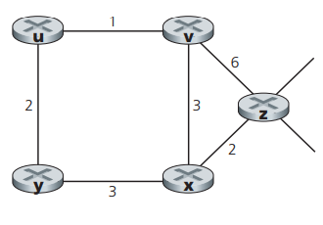

|  |  |  |  |  |  |
| --- | --- | --- | --- | --- | --- |
|  | U | V | X | Y | z |
| V | ∞ | ∞ | ∞ | ∞ | ∞ |
| X | ∞ | ∞ | ∞ | ∞ | ∞ |
| z | ∞ | 6 | 2 | ∞ | 0 |

|  |  |  |  |  |  |
| --- | --- | --- | --- | --- | --- |
|  | U | V | X | Y | z |
| V | 1 | 0 | 3 | ∞ | 6 |
| X | ∞ | 3 | 0 | 3 | 2 |
| z | 7 | 5 | 2 | 5 | 0 |

|  |  |  |  |  |  |
| --- | --- | --- | --- | --- | --- |
|  | U | V | X | Y | z |
| V | 1 | 0 | 3 | 3 | 5 |
| X | 4 | 3 | 0 | 3 | 2 |
| z | 6 | 5 | 2 | 5 | 0 |

**P7. Consider the network fragment shown below. x has only two attached neighbors, w and y. w has a minimum-cost path to destination u (not shown) of 5, and y has a minimum-cost path to u of 6. The complete paths from w and y to u (and between w and y) are not shown. All link costs in the network have strictly positive integer values.**

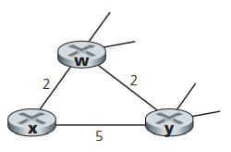

**a. Give x’s distance vector for destinations w, y, and u.**

**b. Give a link-cost change for either c(x,w) or c(x,y) such that x will inform its neighbors of a new minimum-cost path to u as a result of executing the distance-vector algorithm.**

**c. Give a link-cost change for either c(x,w) or c(x,y) such that x will not inform its neighbors of a new minimum-cost path to u as a result of executing the distance-vector algorithm.**

a) Dx(w) = 2, Dx(y) = 4, Dx(u) = 7

b) node x again informs its neighbors of the new cost.

c) not cause x to inform its neighbors of a new minimum-cost path to u.

**P14. Consider the network shown below. Suppose AS3 and AS2 are running OSPF for their intra-AS routing protocol. Suppose AS1 and AS4 are running RIP for their intra-AS routing protocol. Suppose eBGP and iBGP are used for the inter-AS routing protocol. Initially suppose there is no physical link between AS2 and AS4.**

**a. Router 3c learns about prefix x from which routing protocol: OSPF, RIP, eBGP, or iBGP?**

**b. Router 3a learns about x from which routing protocol?**

**c. Router 1c learns about x from which routing protocol?**

**d. Router 1d learns about x from which routing protocol?**

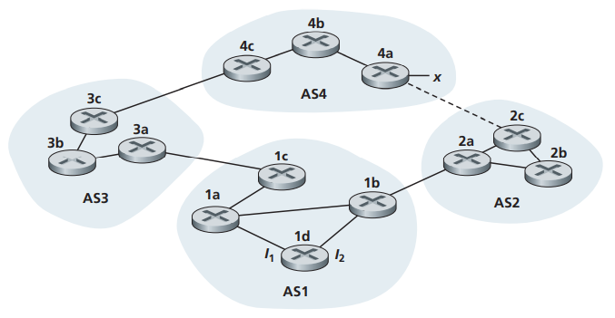

a) eBGP

b) eBGP

c) eBGP

d) iBGP